

MACHAKOS UNIVERSITY

CENTER OF OPEN, DISTANCE AND e-LEARNING

IN COLLABORATION WITH

SCHOOL OF ENGINEERING AND TECHNOLOGY

DEPARTMENT OF COMPUTING AND INFORMATION TECHNOLOGY.

SCO 208 OBJECT ORIENTED ANALYSIS AND DESIGN/
SIT 264 UML

WRITTEN BY:

Mr. Martin Kimeu

Copyright © Machakos University, 2020
All Rights Reserved

SEP, 2021

LESSON 2

OBJECT MODELING TECHNIQUE (OMT)

Unit Structure

- Introduction
- The Rambaugh OMT
- The Booch OMT

- Jacobson OOSE
- Object-oriented software engineering life cycle
- UNIFIED process model
- Views in UML
- UML Diagrams

- INTRODUCTION

The object-modeling technique (OMT) is an object modeling language for software modeling and designing.

It was developed by Rumbaugh, Blaha, Premerlani, Eddy and Lorensen as a method to develop object-oriented systems, and to support object-oriented programming.

- THE RAMBAUGH OMT

The purposes of modeling according to Raumbaugh (1991) are:
- testing physical entities before building them (simulation),

- communication with customers,

- visualization (alternative presentation of information), and

- reduction of complexity.

The Rambaugh OMT has proposed three main types of models:

- Object model : Main concepts are classes and associations, withattributes and operations. Aggregation and generalization are predefined relationships.

- Dynamic model : The dynamic model represents a state/transitionview on the model. Main concepts are states, transitions between states,

XI

and events to trigger transitions. Actions can be modeled as occurring within states.

3. Functional model : The functional model handles the process ofthe model, corresponding roughly to data flow diagrams. Main concepts are process, data store, data flow, and actors.
OMT is a predecessor of the Unified Modeling Language (UML).

- THE BOOCH OMT

The analysis phase is split into steps.

Customer's Requirements Step: The first step is to gather the requirements from the customer perspective. This analysis step generates a high-level description of the system's function and structure.

Domain analysis: The domain analysis is done by defining object classes; their attributes, inheritance, and methods. State diagrams for the objects are then established.

The analysis phase is completed with a validation step.

The analysis phase iterates between the customer's requirements step, the domain analysis step, and the validation step until consistency is reached.

Once the analysis phase is completed, the Booch methodology develops the architecture in the design phase.

The design phase is iterative.

A logic design is mapped to a physical design like processes, performance, data types, data structures, visibility are defined.

A prototype is created and tested. The process iterates between the logical design, physical design, prototypes, and testing.

The Booch software engineering methodology is sequential in the sense that the analysis phase is completed and then the design phase is completed.

The methodology is cyclical in the sense that each phase is composed of smaller cyclical steps.

Drawbacks:

There is no explicit priority setting nor a non-monotonic control mechanism.

The Booch methodology concentrates on the analysis and design phase and does not consider the implementation or the testing phase in much detail.

- JACOBSON OOSE

Object-Oriented Software Engineering (OOSE) is a software design technique that is used in software design in object-oriented programming.

OOSE is developed by Ivar Jacobson in 1992.

OOSE is the first object-oriented design methodology that employs use cases in software design.

It includes requirements, an analysis, a design, an implementation and a testing model.

Object oriented software engineering
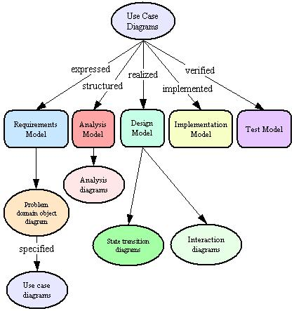

- OBJECT-ORIENTED SOFTWARE ENGINEERING LIFE CYCLE

Requirements Engineering:

o requirements gathering,

o Object oriented analysis and o specification

OO Design:

o architectural design
o detailed design

o both require the transformation of functional requirements into OO design elements

Implementation or Coding:

o Programming using OO programming languages and tools.

Testing:
o unit testing; test methods within each object

o integration testing; test collaborations between objects

- system testing; test the entire system as a collection of objects

  - acceptance testing; test for standards and customer satisfaction

- UNIFIED PROCESS MODEL

Elaborat ion
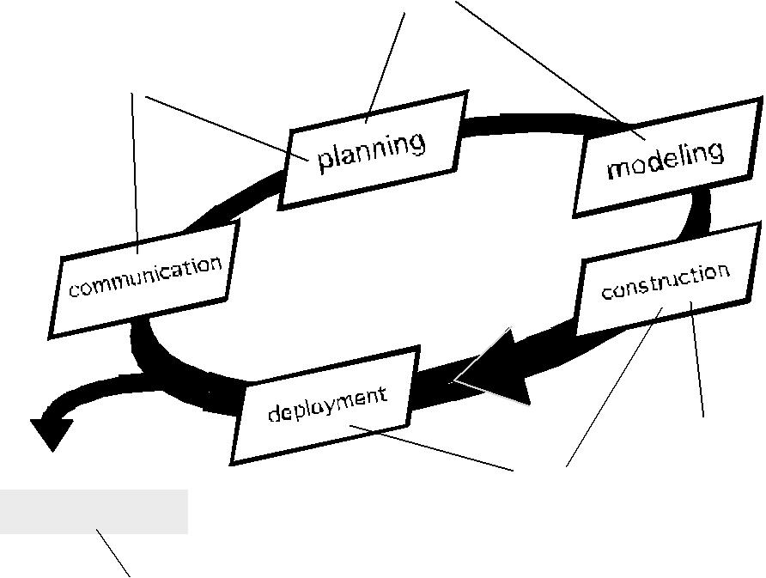

Incept ion

Release

soft ware increment

construction

t ransit ion

production

Iterative and Incremental:

o The Unified Process is an iterative and incremental development process.

- The Elaboration, Construction and Transition phases are divided into a series of timeboxed iterations.

- Each iteration results in an increment, which results in improved functionality .

Use Case Driven:

- In the Unified Process, use cases are used to capture the functional requirements and to define the contents of the iterations.

Risk Focused

- The Unified Process requires the project team to focus on the most critical risks early in the project life cycle.

o The deliverables of each iteration, especially in the Elaboration phase, must be selected in order to ensure that the greatest risks are addressed first.

Introduction to UML

UML is a language used for object-oriented analysis and design.

UML includes a set of graphical notation techniques to create visual models of software systems.

Three developers of UML are Grady Booch, Ivar Jacobson and James Rumbaugh.

UML is a language for visualizing, specifying, constructing, documenting.

UML is not a development method. It is designed to be compatible with the object-oriented software development methods.

- VIEWS IN UML

1. Functional View:

 This view describes functional requirements of the system.

Use case diagrams give static functional view for functions and static relationships.
 Activity diagrams give dynamic functional view.

- Static Structural View:
The class and object diagrams give the structural view of system.

3. Behavioral (dynamic structural) view:

Interaction diagrams- collaboration diagrams and sequencediagrams describe sequences of interactions between objects.

State transition diagrams show state-based behavior of objects.

4. Architectural View:

This view describes logical and physical structure.

Component diagrams and deployment diagrams are used in this view.
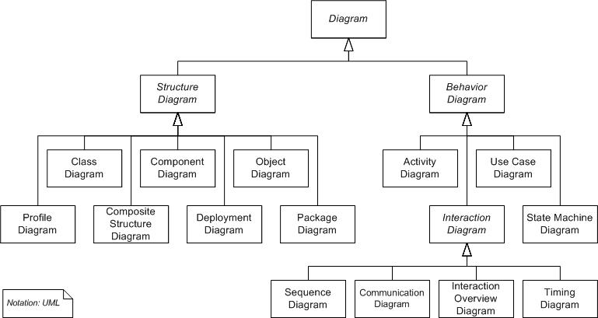

- UML DIAGRAMS

Diagrams are the heart of UML. These diagrams are broadly categorized as structural and behavioral diagrams.

Structural diagrams are consists of static diagrams like class diagram, object diagram etc.

Behavioral diagrams are consists of dynamic diagrams like sequence diagram, collaboration diagram etc.

The static and dynamic nature of a system is visualized by using these diagrams.

Class diagrams:

Class diagrams are the most popular UML diagrams used by the object oriented community. It describes the objects in a system and their relationships. Class diagram consists of attributes and functions.

A single class diagram describes a specific aspect of the system and the collection of class diagrams represents the whole system. Basically the class diagram represents the static view of a system.

Class diagrams are the only UML diagrams which can be mapped directly with object oriented languages. So it is widely used by the developer community.

Object Diagram:

An object diagram is an instance of a class diagram. So the basic elements are similar to a class diagram. Object diagrams are consists of objects and links. It captures the instance of the system at a particular moment.

Object diagrams are used for prototyping, reverse engineering and modeling practical scenarios.

Component Diagram:

Component diagrams are special kind of UML diagram to describe static implementation view of a system. Component diagrams consist of physical components like libraries, files, folders etc.

This diagram is used from implementation perspective. More than one component diagrams are used to represent the entire system. Forward and reverse engineering techniques are used to make executables from component diagrams.

Deployment Diagram:

Component diagrams are used to describe the static deployment view of a system. These diagrams are mainly used by system engineers.

Deployment diagrams are consists of nodes and their relationships. An efficient deployment diagram is an integral part of software application development.

Use Case Diagram;

Use case diagram is used to capture the dynamic nature of a system. It consists of use cases, actors and their relationships. Use case diagram is used at a high level design to capture the requirements of a system.

So it represents the system functionalities and their flow. Although the use case diagrams are not a good candidate for forward and reverse engineering but still they are used in a slightly differently way to model it.

Interaction Diagram:

Interaction diagrams are used for capturing dynamic nature of a system. Sequence and collaboration diagrams are the interaction diagrams used for this purpose.

Sequence diagrams are used to capture time ordering of message flow and collaboration diagrams are used to understand the structural organization of the system. Generally a set of sequence and collaboration diagrams are used to model an entire system.

Statechart Diagram:

State chart diagrams are one of the five diagrams used for modeling dynamic nature of a system. These diagrams are used to model the entire life cycle of an object. Activity diagram is a special kind of State chart diagram.

State of an object is defined as the condition where an object resides for a particular time and the object again moves to other states when some events occur. State chart diagrams are also used for forward and reverse engineering.

Activity Diagram:

Activity diagram is another important diagram to describe dynamic behaviour. Activity diagram consists of activities, links, relationships etc. It models all types of flows like parallel, single, concurrent etc.

Activity diagram describes the flow control from one activity to another without any messages. These diagrams are used to model high level view of business requirements.

